Hayek versus China – Artificial Intelligence and Machine Learning for Domination in Whatsoever Type of Competition

Alex Alaniz, PhD
27 February 2022

Nutshell
- Economics Nobel Laureate Hayek argued that central planning governments, e.g., Russia and China, cannot collect sufficient information for successful central planning, leading to eventual collapse.
- The internet, the internet of things, digital currency, big data, machine learning and artificial intelligence, some recent thinking states, can overcome the information problem of Hayek.
- Chemistry Nobel Laureate Prigogine, using statistical physics, argues that the differential equations underlying human planning have feedbacks that inject chaos, and hence offer no possibility for successful long term central planning. The best solutions are local, such as those that occur in non-centralized, free market, democratic systems.
- New “reservoir” computing methods can predict further in time than merely integrating the differential equations forward in time.
- Reservoir computing, intents, and constraints, coupled with OODA loop networks ‘wargaming’ tools may provide democracies (and competing autocracies) competitive advantages.

Abstract
This article explores how the work in dynamics systems theory by Prigogine and Nicolis favors the domination of democracies over autocracies, capitalist economies over socialist command economies, and free markets over interventionist state-controlled markets, in full concordance with the so-called knowledge problem of Nobel Prize economist A. F. Hayek. (The knowledge problem stipulates that there is never sufficient information for central planning governments to endure, e.g., the collapse of the Soviet Union). Also explored are the recent arguments by Gueorguiev countering Hayek’s knowledge problem. Thanks to the internet and the internet of things (IoT), Gueorguiev contends that China is near having the means for overcoming the knowledge problem. Lastly, the article explores the roles that network topology, artificial intelligence (AI), and machine learning (ML) can play for continued, persistent domination in whatsoever type of topological competition between nation states and their respective political, governmental, and economic systems, down to operational and tactical level conflict.

Executive Summary
“If socialists understood economics, they wouldn't be socialists.”
― Friedrich Hayek
This article explores the domination in whatsoever type of topological conflict through three bounding questions, two and one theories in opposition, and the role of artificial intelligence (AI) and machine learning (ML) in competitions based on Intents/Constraints Observe, Orient, Decide, Act (IC-OODA) predictor-corrector (PC) loops. By topological, it is meant the evolving networks linking nodes together: nations through treaties, markets through supply chains, and individual people through social media, bloodlines, etcetera.

Background: Using dynamic systems theory in 1979, Prigogine and Nicolis informed us that it is more likely impossible for centralized planning bodies to globally optimize the evolution of human institutions and human wellbeing. The equations describing the complex adaptive dynamics of human institutions are inherently chaotic, subject to bifurcation, and constantly undergo spontaneous symmetry breaking. Stabilities here and there are ephemeral, overcome by the emergence of new, ineluctable dynamics: wise, benevolent, or malefactor leaders die while new replacements are born. New, unpredictable technologies spontaneously emerge from underlying technologies, new music styles spontaneously emerge from older music styles, and new forms of government spontaneously evolve from older forms of government: from imperial Rome to feudalism to today’s bipolar world between the United States and its powerful allies and China with its limited friends and partners such as North Korea and Russia.

A Prigogine and Nicolis case in point: The emergence of the internet was predictable by extrapolation of the underlying and rapidly advancing technologies that were being promoted by the US government through the Advanced Research Projects Agency Network (ARPANET) in the 1970s. The simple actions of individuals using the internet across the globe, however, produced complex and unpredictable results. If people expected world-wide-web conviviality, they got, rather, grassroot fragmentation into myriad, post-reality conspiracy theory factions, flat-Earthers, anti-vaxxer movements, white supremacists, nation state botnet disinformation campaigns, deep fakes, dark webs, cybercrime and cyberwarfare, as well as financial system disruption through the emergence of decoupled digital currencies, ad hoc social media network-orchestrated short squeeze attacks, and ransomware attacks to name but a few of today’s information age virological-like emergent phenomenology.

The three bounding questions
1. Given global competition comprised of multiply overlapping, non-linearly interacting, hierarchical geopolitical competitive processes between and within nation states, their forms of government, and the treaties between themselves, is perpetual domination of one type of government, economic framework, and market dynamics possible?
2. More specifically, can democracy within the framework of capitalism (owners and workers) and free trading markets perpetually dominate over autocratic socialism, state controlled command economics and interventionist state regulated markets [Kroenig, 2020]?
3. What roles, if any, will machine learning AI/ML play in such hierarchical Intents/Constraints [Seidenberger, 2022] OODA loop (or IC-OODA PC loop) competitions?

The two and one theories in opposition
1. In 1945, economics Nobel laureate Friedrich Hayek theorized that centrally controlled governments (autocracies/communist states) would always fail to endure as there would always be insufficient information available to these types of central governments for the task of central government planning and execution. Hayek argued that information is decentralized – that knowledge is unevenly dispersed among different members of society – and that as a result, decisions are best made by those with local knowledge rather than by a central authority. This is known as the knowledge problem [Hayek, 1945].
2. In opposition, Associate Professor of Political Science at the Maxwell School of Citizenship and Public Affairs at and Director of Chinese Studies at Syracuse University, Dimitar Gueorguiev, countered Hayek’s argument in January 2022 with respect to, specifically, China. Gueorguiev theorizes that Chinese autocratic communism, thanks to the internet and the internet of things (IoT), finally produces sufficient information for China to succeed under centralized government planning and execution. With the internet and IoT, that is, China can overcome the Hayek knowledge problem.
3. Ilya Prigogine, the 1977 Nobel Prize laureate in chemistry for his work in non-equilibrium statistical physics, along with collaborator Grégoire Nicolis, used dynamic systems theory to theoretically demonstrate the unlikelihood of centralized planning bodies to globally optimize the evolution of human institutions and human wellbeing thanks to the manifold inherent nonlinear feedbacks that power economic chaos and catastrophes in the sense of mathematical catastrophe theory [Prigogine and Nicolis, 1977; Gilmore, 1981].

Topological Network Persistence in Competition
In topological relationships and competition (the ongoing and historical processes of global treaty/trade/conflict-based nation state dynamics, down to our local personal histories, the networks of relationships with our friends, families, neighborhoods, and sports teams) some networks remain persistent over relatively long timescales, often surviving major paradigm shifts, while others fade quickly away. After the collapse of the Soviet Union, the world ceased being bipolar. The current hegemony of the United States is currently giving way to a tripolar world with China and a reemergent Russia leading to a new trivalent cold war. After leaving Brooklyn in 1957, the year of Sputnik nearer the beginning of the Cold War, the Los Angeles Dodgers have remained steadfastly in Los Angeles.

The role of AI and Machine Learning (ML) in IC-OODA PC loop competitions
With respect to topological IC-OODA PC loop competition, the nature of a network typically drives its dynamics. Many of humanity’s networks are so-called small world networks with underlying power law distributions, e.g., wealth distributions. In capitalistic democracies, wealth distributions are not normal, or bell-shaped distributions, but rather power-lawed long-tailed distributions with few billionaires and the rest of us falling off into the tails. In China, billionaires can be disappeared, quickly flattening their nation’s wealth distribution towards a more Mao Zedong-like uniformity.

The characteristic timescale on which a nonlinear, dynamical system becomes chaotic, e.g., the time at which smooth cigarette smoke devolves into chaotic flow, is the Lyapunov time. The Lyapunov time characterizes the limits of the predictability of a chaotic system (of differential equations). Recent work using machine learning model-free prediction in nonlinear systems has led to effective machine learning predictors of spatiotemporally chaotic systems of arbitrarily large spatial extent and attractor dimension to large multiples of the Lyapunov time [Pathak et al, 2018]. In plain speak, AI/ML methods allow for prediction of chaotic flows for significant periods of time after the transition to chaos. IC-OODA PC loop competitors with the better nonlinear system predictors would dominate almost always.
The Arab Spring, toppling four (topologically related) dictators and sparking (topologically related) popular uprisings in several nearby countries, was triggered by a Tunisian man burning himself alive in a powder keg of pent up correlation risk of topologically correlated angry youth and unions across neighboring countries over decades. The amplification of such topological correlation risk to fuel social division and discord by AI/ML IC-OODA PC loop social media weapons would likely extend naturally from the marketing departments of the giant social media companies. IC-OODA PC loop topological competitors (in some given dynamical geopolitical network market structures, kill webs, etcetera) armed with the best IC-OODA PC loop AI/ML predictors could, in principle, hack democracies and/or autocracies by fomenting new Tiananmen Square-like uprisings or 6 January 2021-like attacks on the US Capitol.
A good starting point for AI/ML methods to hack nation states and their allies is through the use of perturbative post-Darwinian IC-OODA PC loop exploration of systems of systems operating in heat (or entropy) baths. The attainment of artificial general intelligence (AGI) may, or may not, be requisite for driving sustained IC-OODA PC loop domination.

The resolution in brief
After conjoining Hayek with Prigogine and Nicolis to Hidalgo [Hidalgo, 2015], it is argued in this paper that the best economic solutions, found under conditions of non-equilibrium, emerge when local competitors are given the free market freedom to explore the entropy of evolutionary solutions using reservoir machine learning methods designed to predict future states in complex adaptive systems [Pathak et al, 2018]. There are many ways to generate heavier than air flight for different ends and purposes: flies, birds, bats, locusts, and, after the respective emergences of hominid intelligence, language, civilization, science and engineering, B-52 BUFFs, F-16 Fighting Falcons, F-15 Eagles, and F-22 Raptors. Democracy, with its reduced frictions, outraced autocracy to the moon during the Old Cold War. On the way to Mars, the private enterprise, SpaceX, appears to be outrunning China, with its somewhat free market system for unfree people. While autocratic China might get to Mars first, not unlike when autocratic Russia orbited the first human being in space, the free market power of the United States eventually overtook it.
The necessary background to deal with the three bounding questions, the two and one opposing theories, and the role of AI/ML is provided in the body of the work in small, self-contained blocks before addressing the questions, theories, and the roles of AI/ML for domination in whatsoever form of topological competition.

References
F. A. Hayek, The Use of Knowledge in Society, The American Economic Review, Volume Thirty-Five, Number Four, September 1945
C. Hidalgo, Why Information Grows: The Evolution of Order, from Atoms to Economies, Basic Books; Illustrated edition, 2 June 2015
D. Gueorguiev, China’s Surveillance State Will Test The West – Digital surveillance could allow China’s leaders to succeed where previous authoritarian regimes have failed, NOĒMA, January 2022
R. Gilmore, Catastrophe Theory for Scientists and Engineers, Wiley Interscience, 1981
M. Kroenig, The Return of Great Power Rivalry Democracy versus Autocracy from the Ancient World to the U.S. and China, Oxford University Press, 2020
G. Nicolis and I. Prigogine, Self-Organization in Nonequilibrium Systems From Dissipative Structures to Order through Fluctuations, John Wiley & Sons, 1977
Jaideep Pathak, Brian Hunt, Michelle Girvan, Zhixin Lu, and Edward Ott, Model-Free Prediction of Large Spatiotemporally Chaotic Systems from Data: A Reservoir Computing Approach, Phys. Rev. Lett. 120, 024102 – Published 12 January 2018
Capt S. Seidenberger, USAF, Personal Communication on adding Intents and Constraints to the OODA PC loop, 2022

Limits of Historical Dynamics
Many historical processes are mathematically dynamical: the growth and decline of populations, territorial expansion and contraction of empires, trends in political centralization or decentralization, the spread of world religions, diseases, technologies, and cultures to name but a few examples. In Historical Dynamics Peter Turchin introduces methods of Asabiya (a concept of social solidarity with an emphasis on unity, group consciousness, and a sense of shared purpose and social cohesion) to his differential equation-based empirically powered stochastic models of the rise and fall of European empires between the collapse of Rome and the beginning of the Industrial Revolution [1].
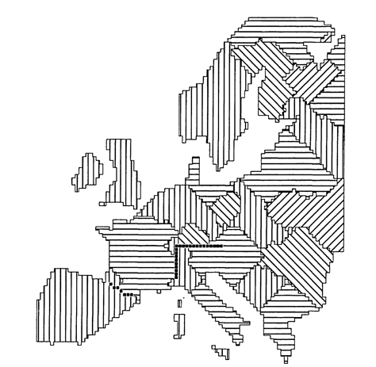
For a highly simplified model of the rise and fall of empires, consider a model with the following minimal dynamics: Success in war leads to an expansion in territorial size. In turn, a larger territory leads to more resources, which give an advantage in future wars. But a large empire has a longer border to defend, and big territories are more difficult to govern. Marc Artzrouni and John Komlos simulated the co-evolution of computer generated ‘states’ driven by such historical forces. During 3,900 iterations, virtual states expanded, contracted, and disappeared on a Europe-shaped map. Surprisingly, a number of simulations resulted in a configuration that resembles that of modern Europe A.D. 1800: Spain, Italy, and Britain are clearly visible.
Beyond the Industrial Revolution, the accelerating pace of industrial innovation overwhelms such simplified modeling methods. Without the assistance of AI/ML methods, such simplistic statistical modeling methods cannot handle the effects of exponential technological advancement that enabled the emergence of world wars in the previous century.

Hayek’s information problem in brief
In, “The Use of Knowledge in Society”, Nobel Laureate Friedrich Hayek argued in 1945 that information is decentralized – that knowledge is unevenly dispersed among different members of society – and that as a result, decisions are best made by those with local knowledge rather than by a central authority.
Hayek's article argues against the establishment of a Central Pricing Board by highlighting the dynamic and organic nature of market price-fluctuations, and the benefits of this phenomenon. Hayek asserts that a centrally planned economy will never be able to match the efficiency of open markets because what is known by a single agent is only a small fraction of the sum total of knowledge held by all members of society. A decentralized economy thus complements the dispersed nature of information spread throughout society. In Hayek's words, "The marvel is that in a case like that of a scarcity of one raw material, without an order being issued, without more than perhaps a handful of people knowing the cause, tens of thousands of people whose identity could not be ascertained by months of investigation, are made to use the material or its products more sparingly; that is, they move in the right direction."

Arguments Countering the Knowledge Problem of Hayek Inspired from ‘China’s Surveillance State Will Test the West’, Gueorguiev 2022
Heterodox economists like Friedrich Hayek and Ludwig von Mises have long argued that control regimes are bound to stumble due to their inability to collect all the information necessary for making globally optimal decisions, and much less process the information if all the necessary information were available (the problem of computational complexity). If one reviews the trajectories of democracies over autocracies over the millennia, only liberal societies using free markets have been able to efficiently solve the knowledge problem and the problem of computational complexity. The difference being that control regimes work at computing global solutions, whereas liberal societies using free markets, come across local solutions much the same way Darwinian evolution derives local solutions for local problems. Polar bears are not endemic to equatorial latitudes.
Nobel laureate Amartya Sen observes that authoritarian regimes lack the incentive or the infrastructure necessary for “enhancing the hearing that people get in expressing and supporting their claims,” the absence of which prevents government from acting in a responsive or accountable manner. The hearing of the people is a noisy, messy problem for democracies, but debate and compromise often produce better solutions than some rigidly, autocratically imposed “right” solution from dear leader.
Paradoxically, China’s one-party government often comes across as hypersensitive to public opinion, citizen complaints, and social media sentiment. As the Australian political scientist John Keane noted, China’s leaders are so fearful of the loss of control that comes along with democracy that, ironically, they act like elected officials in the West who constantly plumb the public mood in the hope of winning the proverbial ballot.
Despite the internet and IoT, current Chinese leaders must still struggle with information hoarding across the vast administrative structures of the country. Even in areas where micromanagement is strong, anecdotal evidence suggests attention remains on loyalty, not efficiency.

Bottom up Information, Digital Currency, and Digital Infrastructure for Top Down Control from the Bottom Up
In recent years, Chinese authorities have overcome some top-down information gaps by enlisting the help of average citizens who volunteer bottom-up input, investing in centralized databases, and rapidly expanding artificial intelligence. Retrofitting China’s analog system of control with technologies that facilitate both information aggregation and information processing could well allow it to avoid the pitfalls that made the Leninist model fail so miserably during the Soviet industrial age – and could place China ahead of the curve in strategic competition with the West.

Digital Currency: China and US
China has by and large chosen its path, piloting state-backed digital currency while laying waste to mining and finance activities tied to decentralized cryptocurrencies like Bitcoin. Unlike paper RMB, e-RMB operates around an immutable distributed ledger, making it both infinitely easier to track and impossible to corrupt, thus offering the CCP its preferred blend of capacity and control. Importantly, digital RMB will likely be highly attractive to China’s tech-savvy population – an e-RMB wallet app is already available in the Apple and Android stores. (RMB is the digital version of the people’s renminbi, the coins and bills of China’s official currency, while e-CNY (or just CNY) is the digital version of the Yuan, the unit of account of the country’s economic and financial system.)
The ongoing introduction of electronic currency will give China’s government unprecedented ability to track individual and institutional transactions from the bottom up. In the not-so-distant future, China’s government will not only have insight into how the people spend scarce resources. China will also have the vision to decide who deserves more and who will settle for less. Digitization makes it easier for China’s planners to optimize capital disbursements and micromanage transactions at home. When the Chinese government injected consumer stimulus in response to the large-scale COVID lockdown in the spring of 2020, it did so with time-sensitive digital vouchers that had to be spent on local goods and services. Soon, large amounts of digital transaction data and blockchain strategies will make it possible to train probabilistic models for selective stimulus to residents, targeted investment in public and private directed firms and even for pricing complex market externalities like carbon emissions.
Digital currency also offers safer vehicles for challenging the U.S. dollar abroad, such as by offering preferential financing to other countries using China’s Interbank Cross-Border Payment System (a competitor of the Belgian-based SWIFT system) or by invoicing trade via e-RMB smart contracts. To the extent that such a system gains traction, China’s central planners will see domestic fiscal control and international monetary influence grow in tandem.
In the U.S., pressure is also growing on the Fed, Treasury and regulators to jumpstart plans for a digital dollar, and there is growing indication that the powers that be are taking note. For some, like Fed Governor Christopher Waller, a dollar-based CBDC is unlikely, given the diffuse nature of American banking at the federal, commercial and regulatory levels.

Digital infrastructure
Thanks in part to the advent of digital technologies, China’s leaders are reaching a point where they believe they have sufficient tools to overcome and move past the computational challenge of managing ever more complexity by deepening control through connectivity. Digital control in China operates as a dual-use technology – repressive in a security sense but progressive from a socialist one. On the one hand, it serves a conventional coercive function by keeping tabs on 1.4 billion people and letting them know it. On the other, it facilitates public polling, responsiveness, oversight, and probabilistic forecasting enabled by massive caches of aggregated data on individual and group-level behavior.
Smartphones and facial recognition, for instance, make it near impossible for dissidents or protesters to organize. These ubiquitous technologies also make it easier to fine jaywalkers or redirect traffic in case of a jam. Public complaints about corruption can be weaponized for political purges, but they are also a tool against self-serving officials who embezzle or waste public funds. Social credit scores help the state coerce a preferred form of citizenship, but they also help alleviate mistrust and risk in China’s unruly consumer market.
Chinese management through increased monitoring and machine learning-based analysis of digital information is hardly yet a perfect system. The information generated through public polls or online complaints is bound by perceptions about what the state deems appropriate, rightful, and legitimate. Even the passive surveillance provided by hidden algorithms will be biased by the conscious or subconscious self-censorship of their unwitting victims. Social credit scores can and will be exploited.
The Chinese system cares less about nuance and more about deviations of any kind that would escape the cosseted design of society imposed by the Party’s vision. Why the public prefers one policy over another or whether a dangerous dissident was in fact a constructive critic does not matter. In other words, the CCP operates in a system of echoes in which the data points of individual behavior, crude as they may be, add up in large numbers and offer the regime a remarkably detailed picture from which to exert control – or what it calls “stability.” (Stability is a fleeting phenomenon in nonlinear dynamics.)
When the global financial crisis struck in 2007, rigid, information-based capital controls shielded financial institutions from some of the volatility. Most recently, monitoring many streams of online data, China has proven almost uniquely adept at controlling the spread of the coronavirus, despite the risks posed by its large and densely packed urban centers. These triumphs have emboldened the regime to pursue further “global” controls, digital and analog, to micromanage life across more and more platforms, from restrictions on entertainment and education to regulatory crackdowns on national champions in the corporate sector.

Emergence of chaotic corruption through micromanagement
The computational complexity of micromanaging a political economy, however, presents the autocrat with a predicament. Autocrats can constrain economic actors, hobble their administrations, and suppress the voice of citizens in efforts to simplify their computational problems. The more a regime attempts to coerce down economic and administrative actors, the more corrupted the system becomes. Coercion contributes to the loss of control that coercion was meant to tame, e.g.,
- The 2020 – 2022 Chinese property sector crisis is a current financial crisis sparked by the financial difficulties of Evergrande Group and other Chinese property developers in the wake of new Chinese regulations on these companies' debt limits
- The 1920s bootlegging in the US during prohibition
After prohibition was repealed, the sophisticated black-market business schemes and money-laundering tactics of organized crime remained. The biggest gangs shifted their operations away from alcohol and into secondary businesses like drugs, gambling, and prostitution. China’s top anti-corruption officials have launched a nationwide audit of major financial firms and regulators to eliminate risk in the sector, following debt crises at state-owned financial conglomerate Huarong and private property developer China Evergrande.
The problem that tighter micromanagement leads to increased corruption, increases the logistic feedback that drives the inescapable existence of nonlinear dynamics with the full spectrum of nonlinear behaviors: chaotic transitions between strange attractors such as market crashes and the emergence of entirely new behaviors. Paradoxically, then, only in the limit of no micromanagement, or complete laissez faire, would causes for corruption disappear. “Corruption free”, however, is not how history characterize laisse faire systems.
Taking a middle ground approach, if an authoritarian regime relinquishes some control to a market system, it frees itself from complex computational challenges such as setting prices. While this may result in a more vibrant economy, as it has for China, it comes at the cost of governance challenges by proliferating nodes of power outside the control capacity of the regime, e.g., Chinese billionaires and celebrities currently being quietly disappeared [2, 3].

The Costs of Control Above and Beyond Corruption
Time and again, the Chinese Communist Party (CCP) has proven remarkably willing to let the economy and citizens absorb the costs of control. Such developments should be seen not so much as miscalculations on the part of administrators but as a testament to their tolerance for inflicting damage on their own economy in the service of control. Recent regulatory crackdowns, for instance, have wiped more than 1 trillion dollars in market value from the books of leading Chinese tech companies. Most recently (2021 – 2022), large swaths of the country have fallen under electricity blackouts due in part to national efforts at reducing emissions in China’s exceedingly dirty energy sector.
The CCP may be increasingly inclined to impose costly controls because it feels powerful enough to reap the political benefits while socializing the economic costs. Some of this attitude is on display in the form of old-fashioned coercive redistribution, e.g., the new “Common Prosperity” campaign, obliging China’s rich and powerful to give away portions of their fortune to the poor and up-and-coming.
These costs of control are not trivial. State censorship over China’s media, for instance, has undercut the country’s soft power abroad. The China Global Television Network (CGTN), China’s flagship international network, commands only a fraction of the audience enjoyed by Qatar’s Al Jazeera English. It is only reasonable to expect that the CCP’s increased assault on scholars and entrepreneurs will have a similar effect on China’s research and innovation potential.

Reduction in Degrees of Freedom
Markets, of course, are not perfect. As recent supply chain failures and the compounding tragedy of climate change make clear, markets have a tough time absorbing shocks and pricing externalities. Even in the best of times, market transactions suffer the inefficiencies of unwanted variability, or what the Nobel prize winning economist Daniel Kahneman refers to simply as “noise.” The computational problem for centralized, control-based governments dealing with innate system complexity comes to the fore here. The empirical record continues to show that state planning consistently underperforms market forces. China, nevertheless, feels competent enough to trade off the costs of control against potential efficiency gains on offer from free market dynamics, e.g., recent anti-monopoly controls by China against its “private” big-tech sector – a drama also playing out in the United States and Europe.
A big risk to China, as well as the US and Europe, is that government intervention will deter private investment and innovation and, in China’s case, cede opportunities to less efficient state-run firms. The question for China is if the tech-enhanced state can direct capital into productive state ventures on-par with or better than private hands, an unprecedented achievement in the historical record. Given that the best economic, technological, policy and other types of solutions are more typically found under conditions of non-equilibrium, emerging when competitors are given the free market freedom to explore the entropy of evolutionary solutions, China’s censorship, regulatory crackdowns, and rigid policy planning of picking winners and losers among their state owned enterprises (SOEs), handicaps the ability of Chinese communism to dominate over global democracies. Democracies, even with their sometimes successful and sometimes useful anti-monopolistic campaigns, can explore spaces with larger, freer degrees of freedom than can China under its system of communism. Directing Chinese capital into productive state ventures on-par with or better than private hands is hobbled by having access to fewer degrees of freedom to explore.

Unpredictability of (Meta)Humanity according to Prigogine and Nicolis
People don’t wake beside random spouses, let out a random dog from a random house filled with random kids running about a random neighborhood, eat a random breakfast, and report to a random job at a random address. Grocery stores remain at fixed locations over decades. Wikipedia links, while subject to potential corruption, are not stochastic. History (and Wikipedia) steadfastly record that Albert Einstein’s relativity displaced Newtonian physics and that Lise Meitner first calculated the yield of splitting the uranium atom. While dynamic in nature, our families, our friends, our towns and cities, as well as our governments persist for some periods of time, but wheretofore our incalculable tomorrows slip to, between imperceptible shifts and jarring shocks, are the realms of fathomless evanescent butterflies dancing in chaotic fogs [4].
Getting into the weeds of Nobel Laureate Ilya Prigogine and coauthor Grégoire Nicolis, consider, for a population at large, two options $α$ and $β$ with two preference levels $A_{α}$ and $B_{β}$, and two evolving sub-populations $X_{α}$ and $X_{β}$ that may choose either $α$ or $β$. The feedback dynamics, to first order, follow the balance equations:
$${\dot{X}}_{α}=aX_{α}\left(\frac{X_{β}A_{α}}{A_{α}+A_{β}}-\frac{X_{α}A_{β}}{A_{α}+A_{β}}\right) \\ {\dot{X}}_{β}=aX_{α}\left(\frac{NA_{α}}{A_{α}+A_{β}}-X_{α}\right)$$
where $X_{β}=N-X_{α}$. When generalizing to $K$ such partitions with $A_{ij}$ transition coefficients
$${\dot{X}}_{i}=CX_{i}\left(1-\frac{X_{i}}{\sum_{j=1}^{K}{{N_{j}A_{ij}}/{\sum_{i}{A_{ij}}}}}\right), i=1,…,K$$
the equations become highly nonlinear, suffering multiple solutions branching over complicated bifurcation phenomena. Different initial conditions result in different basins of attraction producing different evolutions and different future histories.
Recording a particular history among myriad possible histories doesn’t represent the actions of rational global planners attempting to optimize some overall utility function, but simply captures a particular pattern with some level of stability. Depending on time and location, perturbations towards new metastable states may take, grow, and stabilize, or oscillate periodically, or oscillate chaotically, or simply fade away unnoticed. The adaptive possibilities of societies are the main source allowing them to survive long term, to innovate of themselves, and to produce originality. Innovations and innovators rewrite the equations, and more so in democracies than in autocracies [5].
Genocidal autocratic dear leaders with their alternative facts, red books, gulags, gallows, and gas chambers, their Big Brother secret police and social credits, supported by eternally aggrieved brownshirts and pseudo religious warriors, prefer a steady state:
$$\left\{\begin{matrix}X_{i}=C, i=ubbermen \\ X_{i}=0, i≠ubbermen\end{matrix}\right\},$$
where $C$ is a constant.
Strikingly, the non-too dissimilar differential equations of gene networks are anything but chaotic, driving, rather, homeostatic processes [6]:
$${\dot{x}}_{i}\left(t\right)=-λ_{i}x\left(t\right)+\sum_{j=1}^{K}{W_{ij}x_{j}\left(t\right)+b_{i}\left(t\right)+ξ_{i}\left(t\right), i=1,…,K}.$$
Perhaps more stable methods of government and commerce may yet be inspired by homeostatic biological systems.

Human and nature dynamics (HANDY) model, a Hayek, Prigogine and Nicolis case in point
In the HANDY model [7]:
$${\dot{x}}_{C}=β_{C}x_{C}-α_{C}x_{C}, \\ {\dot{x}}_{E}=β_{E}x_{E}-α_{E}x_{E}, \\ \dot{y}=γy\left(λ-α\right)-δx_{C}y, \\ \dot{w}=δx_{c}-C_{c}-C_{E},$$
$C$ stands for commoners and $E$ for elites, $β$ is the birthrate, $α$ is the death rate, $C_{E}$ and $C_{C}$ are the consumption of elites and commoners, and $C_{C}$ is subsistence wage per capita times commoners’ population. The $α_{E}, { α}_{C}, C, E$ are taken to be functions of $w, x_{C}, x_{E}$, where $w$ stands for accumulated wealth. The modeling of natural resources is an amalgamation of nonrenewable and renewable resources with regeneration term $γy\left(λ-α\right)$ and depletion term $-δx_{C}y$. The regeneration term is written in a logistic equation form (which is subject to chaos and bifurcation) with a regeneration factor, $γ$, with exponential regrowth for low values of $y$, and saturation when $y$ approaches $λ$, where $y$ stands for the level of natural resources.
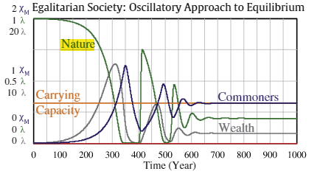
Many equilibria and non-equilibria dynamics are possible in the HANDY model. Below is a case for an approach to equilibrium:
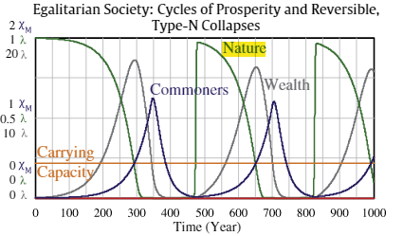
In the figure below, with different parameters, is a case for boom/bust cycles:
Thanks to the presence of the regeneration term (a term of feedback following the logistic equation) it is possible to find a large set of initial conditions leading to chaotic dynamics.

Review of Rabbit Population Logistic Equation Dynamics, Bifurcation, Period Doubling, and Chaos
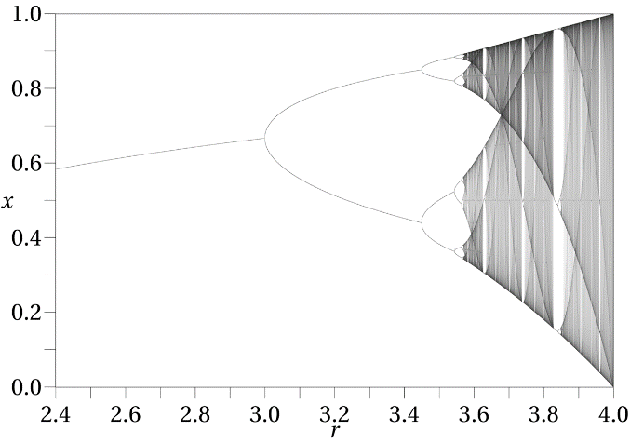
The logistic equation (or map) is: $x_{N+1}={rx}_{N}\left(1-x_{N}\right)$, where $r$ is the growth rate and $x_{N}$ is the ratio of existing bunny population to the maximum possible population. Chaotic behavior arise from this simple non-linear dynamical equation as $r$ varies.
With $r$, the reproduction rate between 0 and 1, the population eventually dies independent of the initial population. With $r$ between 1 and 2, the population quickly approaches the value ${\left(r-1\right)}/r$, independent of the initial population. With $r$ residing between 2 and 3, the population will also eventually approach the same value as in the previous sentence, but it will fluctuate around that value for some time before asymptotically settling down. With $r$ between 3 and $1+\sqrt{6}$, from almost all initial conditions the population will approach permanent oscillations between two values – the population, that is, bifurcates, oscillating one year from the low value to the high value and back again – period doubling. With $r$ between 3.44949 and 3.54409 (approximately), from almost all initial conditions the population will approach permanent oscillations among four values, the next bifurcation and period doubling, and so on.
In dynamical systems theory, a period-doubling bifurcation occurs when a slight change in a system's parameters causes a new periodic trajectory to emerge from an existing periodic trajectory—the new one having double the period of the original. As can be seen in the figure above, as $r$ continues to grow, the period doubling phenomenology explodes chaotically (and effectively unpredictably).
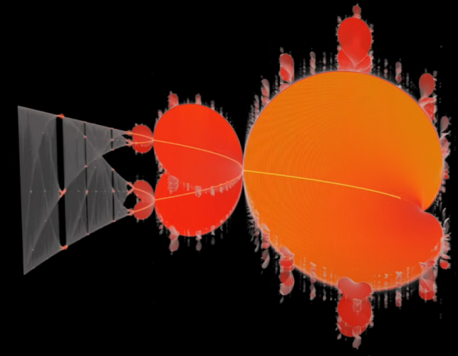
The cause of logistic equation bifurcation is its recursion. The logistic map falls along the center of the three-dimensional Mandelbrot set! (See Veritasium YouTube.) Recursion, therefore, is a a necessary condition for chaos, and chaos ensues from almost all initial conditions (ICs). Some ICs lead to stability.

Background on the OODA loop of Col Boyd, USAF
The predictor-corrector method developed by Col John Boyd in the 1950s: the Observe, Orient, Decide, and Act (OODA) loop is a concise tool for navigating the networks of reality in conflict situations to win fights. OODA loop theory was initially developed for fighter pilots. In a dogfight, the pilot who can run through the OODA loop faster forces the opposing pilot to react – ditto for boxers or tennis players.
Beyond dogfights, Boyd eventually theorized that corporations, governments, and militaries, all connected over myriad networks (communication channels, geopolitical relationships, geographical relationships…) possess hierarchical OODA loops at the tactical, operational, and strategic levels. The most effective organizations, Boyd believed, are those with decentralized chains of command utilizing objective-driven orders rather than method-driven orders to harness the creative abilities of individual leaders at each level. Method-driven orders restrict degrees of freedom and ignore local, decentralized ground truth to better inform objective-driven goals. Accordingly, OODA loop theory aligns well with Hayek as a tool for finding locally optimal solutions in complex, adaptive systems built from networks of systems of systems (SoSs).
In competitive interactions of whatsoever nature between intelligent agents, the agent who observes the surrounding networks and their dynamics in relation to the opposing agent with quicker and greater accuracy, can orient itself more quickly, decide on a course of action more quickly, and take action more quickly over its slower, less situationally aware adversary. In this sense, Boyd’s OODA loop put substance to one of Sun Tzu’s aphorisms: the successful general dictates the nature of battlefield combat, compelling the opposing general to fight on his or her ground and his or her terms.
Implicit in the OODA loop framework is the intent of the competitor (or warfighter) and the constraints of the problem space. Explicitly calling out intents and constraints in the OODA loop framework, as in, IC-OODA loops, forces planners, logisticians, weaponeers, and related support teams to avoid under (or over) specifying battlespaces.
To dominate in a fog of nonlinear war, topological IC-OODA loop-based fighting methods developed from constructive modeling and/or virtual wargaming studies employing predictor-corrector methods should, therefore, be explored to predict, create, and hone advantageous IC-OODA PC loop-based tactics, techniques, and procedures. Literature with key words: OODA loop AND control theory, is to be found online across a spectrum of real-world (military) problems [8-13].

Topological Networks and Dynamics – A Ubiquitous Battlespace for IC-OODA PC loop Competitions
Many kinds of networks exist in nature or have been engineered by human genius. Among the most common networks in both natural and human-based networks is the ubiquitous small world network.

Small World Networks – A Common Battlespace
While many distinct types of network topologies exist, small world networks underlie much of the dynamics of (meta)humanity and potentially explain how our brains can change subjects so quickly [14]. A small-world network is a type of mathematical graph in which most nodes are not neighbors of one another, but the neighbors of any given node are likely to be neighbors of each other and most nodes can be reached from every other node by a small number of hops or steps, e.g., any two persons in the world are at most six degrees of separation from each other (really far less). The author’s spouse worked for an eventual Texas Supreme Court Justice, for whom, in a third degree of separation, President George W. Bush campaigned, and from George W. Bush it’s only one step to the Pope and so forth to almost anyone on the planet.
More specifically, a small-world network is defined to be a network where the typical distance, $D$, between two randomly chosen nodes (the number of steps required) grows proportionally to the logarithm of the number of nodes, $N,$ in the network, $D ∝\log{N}$. Some small world nodes (such as popular YouTubers) are highly connected, but most nodes have few connections. Small world networks such as Instagram allow for videos from unknown small time YouTubers to pop up and go viral from time to time. Going viral exemplifies a catastrophe in the mathematical sense.
Small world networks have many interesting and exploitable properties. Most Tweets and YouTube posts quickly fade away. Occasionally, a Tweet produces a massive shock (it goes viral). Research based on Fundamental Interpersonal Relations Orientation (FIRO) theory [15] suggests that to increase the odds of creating a viral shock, one should target netizens who seek to be individualistic, altruistic, and are content hungry [16]. These people will pass your message on. Meanwhile, avoid netizens seeking personal growth [17]. Knowing who is better at spreading information, and hence who to target for information campaigns, reference [18] includes a case study of successful internet weaponization for fake news, [19] an elaboration on ways to weaponize artificial general intelligences (AGIs) for social engineering, and [20] a study of the algebraic topology of scientific collaboration networks. Researchers should seek methods to automate these approaches to hacking small world internet battlespace networks using IC-OODA PC loop to promote division and distrust in adversary nation states.

Nothing new under the sun: Weaponization of the science of fake news with mathematical feedback metrics
Many studies going back decades demonstrate that Fake News is a viable weapon. One early study in the 1970s tested the phrase “French horn players get cash bonuses to stay in the U.S. Army” [22]. The study concluded that the more a lie (or a truth) is repeated, the more believable it becomes. Other work has shown “fake news” travels faster [23]. Thanks to the pervasiveness of the Internet of Things (IoT), big data, and social media, it is possible to design machine learning mathematical feedback metrics to tune Fake News campaigns [24-27] towards herding (correlation) or catastrophic events, e.g., fomenting crowds towards precipitous violence by increasing correlation risk within generally unpredictable complex adaptive systems. Reference 27 introduces the synchronizability matrix to characterize the maximum synchronizability of a network. Several new concepts, such as sensitive edge and robust edge methods, are being proposed for analyzing the robustness and fragility of synchronization of a network.

Small world networks in China
There is work regarding small world Chinese shipping port networks [28] and airports with respect to spreading disease [29], a topic of high value after the COVID-19 pandemic. It should not surprising that the Chinese are interested in small world networks [30], with applications to cultural dynamics not being ignored [31]. The literature, however, is poor regarding the characterization of China’s social media. An open question is whether Chinese social media platforms assume small world structure and dynamics. Research is also being carried out on the nature of Chinese propaganda being conducted within China through social media [32]. Perhaps this work by the Chinese is aimed at better control of internal social media networks from insider threats, and/or perhaps to obtain greater political resiliency against external threats from other types of government.
Part of the answer to above question comes in comparing the advantages of democracies over autocracies.
In Democracy versus Autocracy: United States versus China and Russia And a Framework for Machiavellian General Artificial Intelligence Project, Matthew Kroenig’s 2020 book, The Return of Great Power Rivalry, Democracy versus Autocracy from the Ancient World to the U.S. and China, is reviewed. Reviewing the historical record, Kroenig makes a convincing case that throughout the history of democracies from Athens, Republican Rome, the Venetian Republic, the Dutch Republic, Great Britain, the United Kingdom, and of late the United States, the best frameworks for adaptability, innovativity, and originality are well informed, law abiding democracies with well-motivated populations. For citizens of democracies there is reward for risk. For citizens of autocracies, identifying solutions to problems is often too risky. In Stalinist Russia, do-gooders often got tagged as non-conformists by bosses who did not want to look bad, and were often shipped off to some gulag or shot in a ditch.

Power Laws (or Scale Free Laws)
A network is normally distributed when each node has roughly the same number of links to other nodes. Networks where the majority of nodes have few links to other nodes, while a minority of nodes have a large number of links to other nodes, e.g., Twitter and Facebook, have long-tailed distributions (see figure below). These popular social media sites exemplify long-tailed small world networks, which are of intense interest across many fields such as cancer genetics, the internet, languages, wars, etc. Significantly, small scale networks bear the stamp of natural selection by survival and propagation of the fittest.

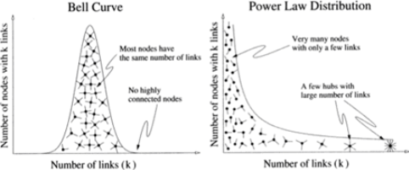
Comparison of a normally distributed network versus a long-tailed network
Small world networks follow power law distributions and are otherwise synonymous with so-called scale free networks.
For an example power law, consider earthquake statistics. Earthquakes of magnitude eight on the Richter scale occur roughly once per year (see figure below). Earthquakes of magnitude seven occur about ten times per year. Smaller tremors of magnitude four occur about ten-thousand times per year, and so forth. Thus, with rounding for the sake of clarity, the number of earthquake events per year, N, for a given magnitude of earthquake, M, follow the power law: N = 9.5¹⁰ M⁻¹⁰. A log-log plot of number of earthquakes by magnitude, with linear slope, is given in the figure below.
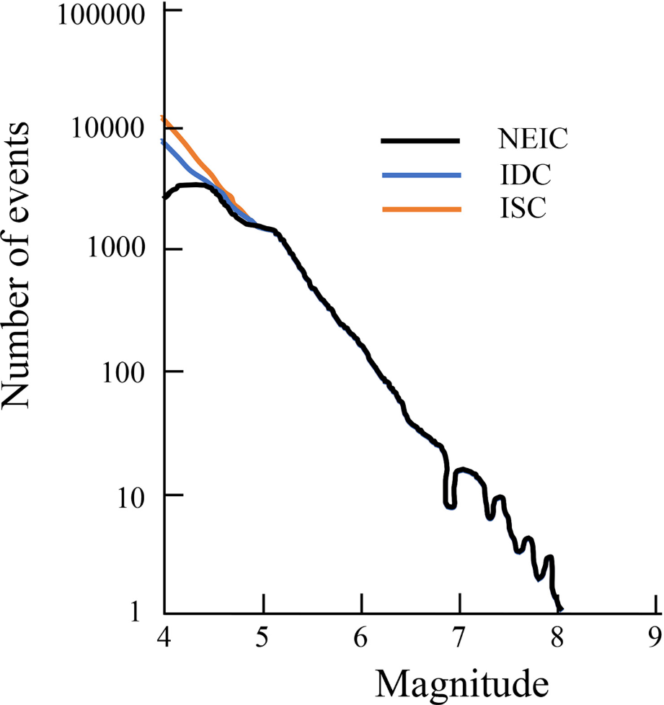
The distribution is said to have a long tail because earthquake magnitudes vary across a large scale from tiny tremors to giant quakes. Adult male weight is approximately normally distributed (see figure below on the left hand side).
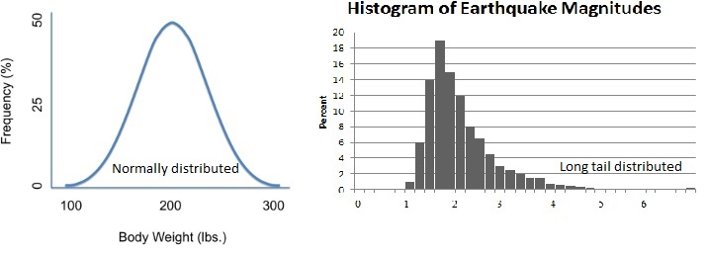
Comparison of normal distribution versus a long-tailed distribution
The occurrence of power law statistics does not guarantee the existence of an underlying network. Small tremors due to fracking in Oklahoma are not related to small tremors in Tibet. Conversely, power laws often indicate the presence of the kinds of scale free networks that can be hacked to create large shocks through social engineering methodologies with bots and trolls on the internet, wars by propaganda, and so forth.
Of key interest to physicists [33], power laws indicate that small world networks organize themselves so that they teeter on the brink between order and chaos, e.g., a crowd synching up that might readily turn into a mob at the slightest provocation [34]. The sudden (catastrophic) change from orderly crowd behavior to uncontrolled mob behavior exemplifies a phase transition, e.g., water heated into steam.
With respect to shaping the battlespace of angry peoples, history offers suggestions for attack by IC-OODA PC loop attacks. On 20 January 2001, President Joseph Estrada of the Philippines became the first head of state in history toppled by a smart mob [1]. More than one-million Manila residents mobilized and coordinated by waves of text messages to assemble at the site of the 1985 ‘People Power’ peaceful demonstration that had toppled the Marcos regime. A few years later, mob-like behavior was repeatedly precipitated on smaller scales during and after the 2016 American presidential election season through Russian Facebook attacks [35-37].

Need for IC-OODA PC loop doctrine for social media warfare – hacking trust
Much as the world’s militaries began developing air power doctrine during and after WW I, military and intelligence departments might do well to begin formalizing doctrinal processes for IC-OODA PC loop social media warfare. Social networks are based on three “hackable” ideas:
- Social foci – Think links created by people sharing social foci: workmates, schoolmates, or AI social media avatars
- Triadic closure – Links formed among people who share friends, or AI social media avatars
- Homophily – Referring to the stickiness of links, e.g., people who like opera.
Trust is key to the development of large social networks. With respect to economies, the presence of industries of different sizes indicates the presence of trust; see Trust: The Social Virtues and The Creation of Prosperity by Fukuyama 1995 [38]. Countries that have vigorous private nonprofit organizations such as schools and hospitals are also likely to develop strong private economic institutions. Trust enables networks and conversely. Trust between diverse races, cultures, and religions is more necessary in cities than in isolated, homogeneous rural areas.
Finally, trust is a form of social capital. Silicon Valley had (has) dense social networks and open labor markets that encourage entrepreneurship. Its former competitor along Route 128 had secretive firms that made employees sign nondisclosure agreements. Silicon Valley obliterated Route 128 out of competition. Trust is why employers tend to hire referrals as referrals are less likely to quit. Building trusting relationships is a slow process, hence why the military moves its people around to forge networks.
The antithesis of trust is division, the gift from social media giants, and fomenting division is highly algorithmic, as Cambridge Analytica can attest to [39]. IC-OODA PC loop methods can likely be engineered to improve on Cambridge Analytica methods.

Self-organized criticality (SOC) and learning in small world networks
Infectious diseases, computer viruses, ideas, and rumors, among many other types of information shocks, can spread like wildfires in small world networks where a minority of nodes have lots of links, e.g., the spread of viral pandemics may be enabled by airports such as John F. Kennedy which link the globe together. (See Forest-Fire Model.) The process of self-organization leading towards behavioral criticality (where phase transitions occur) is of growing interest. In neuroscience, SOC is informing the study of self-organizing recurrent neural networks (SORNs) that in turn inform how biological brains learn [40, 41]. Many experiments have suggested that the brain operates close to a critical state, based on signatures of criticality such as power-law distributed neuronal avalanches. SOC has become a general framework for the study of machine and human cognition [42].
With an eye towards IC-OODA PC loop weaponization, an excellent discussion on SOC and Fake news appeared in Scientific American on 14 July 2017 [42]. There were three key takeaways. The first was that, even in a perfect world where everyone wants to share real news and is capable of evaluating the veracity of every claim, some fake news still reaches thousands (or millions) of people thanks to information overload. The second was that there is not nearly enough time to verify everything online before sharing links. Finally, the third takeaway was that the internet is, not surprisingly, a collection of small world networks. Similar conclusions have been reached in other studies [43].

Catastrophes in small world networks (see Appendix on Catastrophe Theory)
In dynamical systems theory, catastrophe connotes a sudden, irreversible change in the behavior of a dynamical system, e.g., stock market crashes and giant avalanches of snow. Many causes underlie societal catastrophes. All have one thing in common: strong correlation and are subject to SOC:
- In October 1929, news broke out that public utility holding companies would be regulated. A sell-off cascaded through the system as overleveraged (highly correlated) margin investors became forced sellers.
- On 7 December 1941, Imperial Japan bombed Pearl Harbor, sealing its doom as America aligned into an angry, determined correlated people (anticorrelated to Japanese people).
- On 17 December 2010, Tarek el-Tayeb Mohamed Bouazizi set himself afire, precipitating the Arab Spring in a region long on dictators and highly correlated aggrieved citizenries.

The process of self-organization makes contact with the world of dynamical systems theory and complexity theory [2]. Reference 2 details important concepts such as bifurcation, order parameters, nonlinearity, and symmetry breaking. Such is spontaneous symmetry breaking, so that snowflakes, made from symmetrical droplets, take on many shapes. One of the aims of statistical physics is the characterization of critical points and order parameters that lead to instability, bifurcation, changes of phase, symmetry breaking, and new network topology [21]. This field of study should be integral in the designers of warfare by IC-OODA PC loop warfare.

Successful hacks of ‘FundMe’ and Support_Political_Issue websites
The two examples of successful hacking of various kinds of campaign below are only two of many such examples from physicist Albert-László Barabási in ‘The Formula: The Universal Laws of Success’, Little, Brown and Company, 6 November 2018. The experiments are based on using preferential attachment as a network hacking tool. The design of algorithms on complex networks, such as routing, ranking or recommendation algorithms, requires a detailed understanding of the growth characteristics of the networks of interest, such as the Internet, the web graph, social networks, or online communities. To this end, preferential attachment, in which the popularity (or relevance) of a node is determined by its degree, is a well-known and appealing random graph model, whose predictions are in accordance with experiments on the web graph and several social networks. Linear preferential attachment network processes follow the discrete Yule-Simon probability distribution: $f\left(k;ρ\right)=ρB\left(k;ρ+1\right)$ for integer $k≥1$, $ρ>0$, and $B$ is the beta function.

Hacking Change.org
Change.org is an American petition website and a San Francisco-based business with the same name. Change.org has over 400 million users, offering the public the ability to promote the petitions they care about to potential signers in 196 countries to promote change in their communities. Curious how a Change.org campaign gains visibility, sociologist Arnout van de Rijt created an experiment by selecting two hundred early-stage campaigns and granting a dozen signatures to a hundred randomly selected ones [44]. The causes Arnout randomly supported, thanks to preferential attachment, were far more likely to accrue further signatures than those he snubbed. That means that even when we are presented with an issue of potentially deep political or ethical importance, an issue about justice, say, a potential unjust hacking mechanism may come into play. We may think of these petitions as a way to further democracy, but what Arnout discovered is that while all causes are created equal, it is previous success, not a cause’s moral urgency, that drives its later success.

Hacking Kickstart
Kickstarter is an American public benefit corporation from Brooklyn, New York, that maintains a global crowdfunding platform focused on creativity. In a similar experiment hacking Change.org, van de Rijt hacked Kickstart campaigns by giving small amounts of funding at random to half of a group of funding campaigns to study the effects of preferential attachment. The funding campaigns that received small amounts of seed money pulled away from those funding campaigns that received nothing from van de Rijt’s experiment. In the next experiment, van de Rijt tested how multiple random donations to a single source fared. In cases where he withheld funding altogether, 68 percent of projects failed, not attracting other donations. By contrast, only 26 percent floundered when they received one of his blind donations. But when he went as far as offering four blind donations, only 13 percent of the projects failed. In other words, more initial support virtually guaranteed success. Additional donations, however, resulted in progressively smaller returns. A single initial donor attracted 4.3 additional donors. But the three following donors attracted only 1.7 more donors apiece. In monetary terms, van de Rijt’s initial investment, which averaged $24.52, returned a remarkable $191.00 on average. But the return on his three subsequent investments only yielded half of that—$89.57 each. Simply put, the push provided at the get-go by the first donor made a much more significant impact than caused by subsequent donors.
Using preferential attachment (wherein success begets success) as a tool to hack social networks of very diverse natures can likely be weaponized through machine learning and artificial intelligence IC-OODA PC methods.

Persistent success for domination over networks
Persistence, shaped by the willingness to try repeatedly for a breakthrough, eventually pays off. Suppose we can express the success, $S$, of a product (a research paper, a startup, an information campaign…) according to:
$$S=Qr,$$
where $Q$ refers to one’s capability to turn one’s idea into success and $r$ is the merit of the idea. Opening a fast food joint in a crowded mall’s food court is assigned an $r$ value near zero.
Research has shown that one’s individual $Q_{0}$ value does not really improve over time; rather, it remains relatively stable throughout our lifetimes [45]. One strategy to improve $S$ is to collaborate with networks of others (local partners, coworkers, and/or distributed teams) such that
$$S=\sum_{i ϵ Networks}{\left(Q_{0}+Q_{Ne{twork}_{i}}\right)r_{i}}.$$
This approach, of course, extends naturally to firms, and quite likely to nations states, and even to nation state alliances such as the North Atlantic Treaty Organization (NATO). As a leader in some organization, a formulation for everyone’s success would be:
$$S_{self}=\sum_{i}{\left(Q_{0}+Q_{net_{i}}\right)r_{i}}→S_{team} \\ S_{team}=\sum_{j}{\left({Q_{team}}_{0}+Qnet_{team_{j}}\right)r_{j}}→S_{self}.$$
This would extend to intelligent agents employing IC-OODA PC loops to:
$$S_{agent}=\sum_{i}{\left(Q_{0}+Q_{net_{i}}\right)r_{i}}→S_{team} \\ S_{team}=\sum_{j}{\left({Q_{team}}_{0}+Qnet_{team_{j}}\right)r_{j}}→S_{agent}.$$
Following in the next, final section is a specific example of how machine learning and artificial intelligence methods can extend the predictive temporal horizon significantly further than had previously been thought possible in complex, nonlinear systems represented by systems of (higher order) differential equations.

Dynamical systems, complex adaptive systems, and powerful predictive machine learning technologies for IC-OODA PC-based superiority
A complex adaptive system is a system in which a perfect understanding of the individual parts does not automatically convey a perfect understanding of the whole system's behavior [46]. Weather systems and stock markets are complex adaptive systems. Interactions among system elements (or agents) are nonlinear. Small changes due to interactions or external stimuli can effect significant changes in system behavior. Hence the horizon of prediction is generally small. Two infinitesimally near particles of cigarette smoke rising up smoothly near the end of a lit cigarette eventually undergo rapid, turbulent separation, exceeding the prediction power of any supercomputer. Too much error gets integrated far too quickly (see Lyapunov exponent [47]).
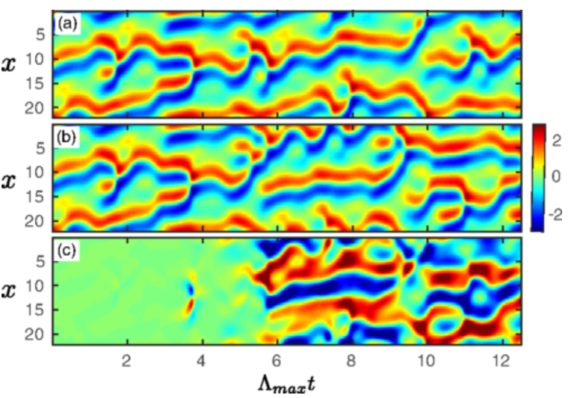
Reservoir computing is a framework for computation derived from recurrent neural network theory that maps input signals into higher dimensional computational spaces through the dynamics of a fixed, non-linear system called a reservoir. Recent work using reservoir computing in nonlinear systems has led to shockingly effective machine learning predictors of spatiotemporally chaotic systems. The figure below compares actual versus reservoir machine learning computing prediction of the Kuramoto-Sivashinsky (KS) equation, a fourth-order nonlinear partial differential equation to model the diffusive instabilities in a laminar flame front [48].

Panel (a) contains the actual data from the KS model. Panel (b) has the reservoir computing prediction. Panel (c) contains the Error [panel (b) minus panel (a)] in the reservoir prediction.

Conclusion
Finite games have winners and losers, the rules of the game are known to both sides, the boundaries of the playing field are well-defined, a scoreboard keeps track of the game’s activity, and at the end of a prescribed period of time, or when options run out, a winner is determined. In infinite games, on the other hand, there no winners or losers. Rules often do not exist, and if they do, they are fuzzy and open to interpretation. The playing field is undefined, and progress is hard to measure. Opponents change frequently, as does the game itself. There are no clear winners or losers in the infinite game. Competitors drop out of the infinite game when they lose the will or resources to stop playing. The goal is to outlast your competition.
Using these definitions, Simon Sinek, author of The Infinite Game, asks a compelling question regarding the Vietnam war: how do you decimate your enemy, win all the crucial the battles and still lose the war? Sinek boils down the answer to the fact that the United States was playing a finite game, aimed at short-term victory, while the North Vietnamese were playing an infinite game, with the goal of outlasting the enemy. Eventually, the Americans simply ran out of the resources and the willpower to stay in the game. In the potentially infinite game between democracies and autocracies, Russia is making a finite game move by invading Ukraine late this February 2022. China is likely gauging the invasion for lessons learned regarding its ambition to invade Taiwan.
In the infinite game, competitions between nation states, between free market economies and command economies, between democracies and autocracies in complex adaptive networked battlespaces, domination will go to those with superior data collection and information processing for finding sufficiently good, local Hayek solutions, an ironic conclusion for autocracies with command economies chasing after global solutions should they ever defeat their free market foes, e.g., China’s use of free markets on their path to world domination through communist centralized government. That more degrees of freedom lead to better local solutions will be hard to overcome.

For winning the peace
IC-OODA PC agent-based reservoir computing machines, or the like, potentially running on quantum computers, should form an initial basis for predicting human preferences relations over all hierarchical spatial and temporal scales
$${\dot{X}}_{i}=CX_{i}\left(1-\frac{X_{i}}{\sum_{j=1}^{K}{{N_{j}A_{ij}}/{\sum_{i}{A_{ij}}}}}\right), i=1,…,K prefernces and A_{ij} transition probabilities.$$
The predictor systems that most accurately predict the future (in the same sense of the best hurricane prediction models at predicting the paths of hurricanes) should be used for handling large scale Monte Carlo simulations out to some reasonable future period of time (most likely between a few days or weeks to at most a few months) to seek out the best plays for increased domination.

For winning war
If the predominant mode of human prediction at the speed of war is linearized Taylor-like prediction, human combatants will soon require battle management aids for handling faster, more maneuverable, and more numerous threats in battlespaces subject to nonlinear complex adaptive behavior. At some point, only superior IC-OODA PC agent-based reservoir computing machines will be capable of dominating competitions in complex adaptive battlespaces by looking as far ahead in Lyapunov time scales as possible. The need for artificial general intelligence for domination is an open question.

Appendix on Catastrophe theory
Catastrophe theory is a branch of bifurcation theory in the study of dynamical systems theory. In the most general sense, it concerns itself with the search for solutions $ψ_{1}\left(t,x;c_{α}\right), ψ_{2}\left(t,x;c_{α}\right),…$ for a system of $n$ integro-differential equations (or worse) defined over a space $R^{N}$ whose coordinates are $\left(x_{1},x_{2},…,x_{N}\right)$:
$$F_{i}\left(ψ_{j};c_{α};t,\frac{dψ_{j}}{dt}, \frac{d^{2}ψ_{j}}{dt^{2}},…;x_{l};\frac{∂ψ_{j}}{∂x_{l}},\frac{∂^{2}ψ_{j}}{∂x_{l}∂x_{m}},…; \int{dx_{l},…}\right)=0$$
where
$$1≤i, ≤n \\ 1≤l, m≤M \\ 1≤α, ≤k.$$
In thermodynamics, catastrophe theory is interesting in the study of:
- Phase transitions (first and second order)
- Critical points and Triple points
- Fluctuations
Can the universe be modeled as object oriented programming (OOP) IC-OODA PC agents in SoSs through reservoir (quantum) computing methods? An agent can be a tree, a forest, Google, or NATO. Where NATO has intents and constraints, a tree does not, and similarly for prediction correction methods.

References
1. Peter Turchin, War and Peace and War, The Rise and Fall of Empires, Plume, 27 Feb 2007
2. J. Wang, Disappearing Billionaires: Jack Ma And Other Chinese Moguls Who Have Mysteriously Dropped Off The Radar, Forbes, 7 Jan 2021
3. A. Su, China is purging celebrities and tech billionaires. But the problem is bigger than ‘sissy men, Los Angeles Times, 14 Sep 2021.
4. Grégoire Nicolis & Ilya Prigogine, Exploring Complexity, An Introduction, W. H. Freeman & Company, NY, 1989

5. M. Kroenig, The Return of Great Power Rivalry Democracy versus Autocracy from the Ancient World to the U.S. and China, Oxford University Press, 2020

6. M. K. S. Yeung, J. Tegne´r, and J. J. Collins, Reverse engineering gene networks using singular value decomposition and robust regression, Edited by Charles S. Peskin, New York University, Hartsdale, NY, March 13, 2002

7. Safa Motesharrei, Jorge Rivas, and Eugenia Kalnay, Human and nature dynamics (HANDY): Modeling inequality and use of resources in the collapse or sustainability of societies, Ecological Economics, 101 (2014) 90-102, Elsevier

8. Vincent Lenders, Axel Tanner, Albert Blarer, Gaining an Edge in Cyberspace with Advanced Situational Awareness, Copublished by the IEEE Computer and Reliability Societies, March/April 2015

9. Magalhães, Marcelo Vellozo, ADAPTIVE NODE CAPABILITY METRIC TO ASSESS THE VALUE OF NETWORKING IN A GENERAL COMMAND AND CONTROL WIRELESS COMMUNICATION TOPOLOGY, Navy Post Graduate School, September 2011

10. MAJOR CHRISTIAN L. BASBALLE SORENSEN, CYBER OODA: TOWARDS A CONCEPTUAL CYBERSPACE FRAMEWORK, SCHOOL OF ADVANCED AIR AND SPACE STUDIES, AIR UNIVERSITY, MAXWELL AIR FORCE BASE, ALABAMA, JUNE 2010

11. Ahmad Shehabat and Teodor Mitew, Distributed Swarming and Stigmergic Effects on ISIS Networks: OODA Loop Model, Journal of Media and Information Warfare Vol. 10, 79-109, Dec 2017

12. Robert Ghrist, Elementary Applied Topology, ISBN 978-1-5028-8085-7, 2014

13. PAN Xing, WANG Huixiong, YANG Yanjing, and ZHANG Guozhong, Resilience based importance measure analysis for SoS, Journal of Systems Engineering and Electronics Vol. 30, No. 5, October 2019, pp. 920 – 930

14. Loukia Papadopoulos, The Human Brain Is Capable of Building Structures With Up to 11 Dimensions, Science, Biology, April 2018.

15. W. C. Schutz, FIRO: A Three-Dimensional Theory of Interpersonal Behavior, New York: Holt, Rinehart, & Winston, 1996
16. J.Y.C. Ho and M. Dempsey, Viral marketing: Motivations to forward online content. Journal of Business Research, 63, pp. 1000 -1006, 2003
17. Nathalie Nahai, Want Your Content to Go Viral? Enter the E-Maven, Psychology Today, 2013
18. Tiffany Westry Womack, Study finds fringe communities on Reddit and 4chan have high influence on flow of alternative news to Twitter, Technology / Computer Sciences, 2 Nov 2017
19. Savvas Zannettou, Tristan Caulfield, Emiliano De Cristofaro, Nicolas Kourtellis, Ilias Leontiadis, Michael Sirivianos, Gianluca Stringhini, and Jeremy Blackburn, The Web Centipede: Understanding How Web Communities Influence Each Other Through the Lens of Mainstream and Alternative News Sources, arXiv:1705.06947v2 [cs.SI] 30 Sep 2017
20. C. J. Carstens and K. J. Horadam, Persistent Homology of Collaboration Networks, Mathematical Problems in Engineering, Volume 2013, Article ID 815035, 19 May 2013
21. James P. Sethna, Order Parameters, Broken Symmetry, and Topology, 1991 Lectures in Complex Systems, Eds. L. Nagel and D. Stein, Santa Fe Institute Studies in the Sciences of Complexity, Proc. Vol. XV, Addison-Wesley, 1992.
22. Lynn Hasher and David Goldstein, Frequency and the Conference of Referential Validity, Journal of Verbal Learning and Verbal Behavior, 16, 107-112, 1977
23. Soroush Vosoughi, Deb Roy, and Sinan Ara, The spread of true and false news online, Science Vol. 359, Issue 6380, pp. 1146-1151, 09 Mar 2018:
24. Jesse Berwald, Tomáš, and John Sheppard, Using machine learning to predict catastrophes in dynamical systems, Journal of Computational and Applied Mathematics, Elsevier, 2011
25. Mohammad Farazmand and Themistoklis P. Sapsis, A variational approach to probing extreme events in turbulent dynamical systems, Science Advances (2017)
26. Omid Askari Sichani and Mahdi Jalili, Inference of Hidden Social Power Through Opinion Formation in Complex Networks, IEEE Transactions on Network Science and Engineering, Vol. 4, No. 3, Jul – Sep 2017
27. Jinhu Lu, Xinghuo Yu, Guanrong Chen, and Daizhan Chen, Characterizing the synchronizability of small-world dynamical networks, IEEE Transactions on Circuits and Systems I: Regular Papers, Vol. 51, Issue 4, April 2004
28. Beibei Hu and Gang Zong, Topology Analysis of China's Port Shipping, JOURNAL OF SOFTWARE, VOL. 8, NO. 10, OCTOBER 2013
29. Jianhong Mou, Chuchu Liu, Saran Chen, Ge Huang, and Xin Lu, Temporal Characteristics of the Chinese Aviation Network and their Effects on the Spread of Infectious Diseases, Scientific Reports, volume 7, Article number: 1275, 2017
30. Eugene Ch’ng, Local Interactions and the Emergence of a Twitter Small-World Network, Social Networking 4(2), p. 33-40, 2015
31. Sun Kai, Mao Xiao-Ming, and Ouyang Qi, Social influence in small-world networks, Chinese Physics, Vol. 11, No. 1280, 2002
32. Gillian Bolsover, Computational Propaganda in China: An Alternative Model of a Widespread Practice, Working Paper No. 2017.4, University of Oxford
33. S. N. Dorogotsvev and J. F. F. Mendes, Evolution of Networks, From Biological Nets to the Internet and WWW, Oxford University Press, 2003
34. Steven Strogatz, Synch, The Emerging Science of Spontaneous Order, New York, 2003
35. David Smiley, Russian syndicate duped Trump supporters into organizing Florida rallies, feds say, Miami Herald, 16 February 2018
36. Claire Albright, A Russian Facebook page organized a protest in Texas. A different Russian page launched the counterprotest, Texas Tribune, 1 Nov 2017
37. Michael Gordon, Charlotte activists were ‘duped’ by Russians, feds say – and it started on Facebook, The Charlotte Observer, 5 Mar 2018
38. F. Fukuyama, Trust: The Social Virtues and The Creation of Prosperity, Free Press, 1996
39. H. Berghe, Malice Domestic: The Cambridge Analytica Dystopia, Computer, IEEE Computer Society, 2018
40. Bruno Del Papa , Viola Priesemann, and Jochen Triesch, Criticality meets learning: Criticality signatures in a self-organizing recurrent neural network, PLOS ONE 12(5): e0178683, 26 May 2017
41. Miguel Aguilera and Manuel G. Bedia, Criticality as It Could Be: organizational invariance as self-organized criticality in embodied agents, arXiv:1704.05255v3 [nlin.AO] 24 May 2017
42. Madhusree Mukerjee, How Fake News Goes Viral—Here’s the Math, Scientific America, 14 Jul 2017
43. Xiaoyan Qiu, Diego F. M. Oliveira, Alireza Sahami Shirazi, Alessandro Flammini, and Filippo Menczer, Limited individual attention and online virality of low-quality information, Nature, Human Behavior, 26 June 2017
44. A. van de Rijt, I. A. Akin, and M. Feinberg, Success-Breeds-Success in Collective Political Behavior: Evidence from a Field Experiment, Sociological Science, October 31, 2016
45. Albert-László Barabási in ‘The Formula: The Universal Laws of Success’, Little, Brown and Company, 6 November 2018
46. Miller, John H and Scott E. Page, Complex adaptive systems: an introduction to computational models of social life. Princeton University Press, 1 Jan 2007
47. Keying Guan, Important Notes on Lyapunov Exponents, Science College, Beijing Jiaotong University, arXiv:1401.3315v1 [math.DS] 14 Jan 2010
48. Jaideep Pathak, Brian Hunt, Michelle Girvan, Zhixin Lu, and Edward Ott, Model-Free Prediction of Large Spatiotemporally Chaotic Systems from Data: A Reservoir Computing Approach, Phys. Rev. Lett. 120, 024102 – Published 12 January 2018

